|  |  |
| --- | --- |
| co_cdphe_emblem_rgb (1) | **Needs Assessment for Planning and Operating SBHCs**  **Created collaboratively by the School-Based Health Center (SBHC) Program at the Colorado Department of Public Health and the Environment (CDPHE) and Youth Healthcare Alliance (YHA)** |
|

This needs assessment tool was created to help you understand your community’s assets and needs and provide quantitative data. The data can help identify the need for the school-based health center and the necessary services, enabling the development of strategies to create positive and sustainable improvements in community health. CDPHE SBHC Program grantees are required to conduct a comprehensive student health needs assessment prior to opening a school-based health center and at least every five (5) years thereafter, per the [SBHC Program Quality Standards](https://drive.google.com/file/d/1YL5mOygx-390etT1_U30PGC-k6EsVkn8/view?usp=sharing).

The needs assessment process can be time-consuming. We encourage you to review the steps and phases outlined in this document to understand the time needed for completion.

**Phase 1: Overview and Advisory Committee**

The first step of the needs assessment is to identify the overall needs in the school district and select the schools and communities where a potential SBHC could be developed. The assessment results will identify priority health needs that will inform organizers of the resources available, gaps in services, and areas for opportunity to meet the needs of students and their families. During Phase 1, it’s helpful to establish an advisory committee to help guide the process by providing insight and feedback. The advisory committee should be a multidisciplinary team representing the school and larger community. Examples of members include school district staff (Director of Student Services, counselors, other administrators), school health staff (nurse, social workers, mental health providers, etc.), teachers (ESL, SpEd, etc.,) local public health authorities, managed care organizations, community-based organizations (youth-specific, LGBTQ+, culturally specific, etc.), community healthcare providers (behavioral health, medical, dental, possible medical sponsors), guardians, and youth. Creating a roster with the advisory committee’s contact information helps keep communication organized.

1. Name and address of school district:
2. Advisory Committee Roster: Who are some people in your community you already partner with or whose knowledge and expertise might support this effort? Insert additional rows as needed.

|  |  |  |  |  |
| --- | --- | --- | --- | --- |
| Name, Pronouns | Role/Title | Organization | Email | Phone |
|  |  |  |  |  |
|  |  |  |  |  |
|  |  |  |  |  |
|  |  |  |  |  |
|  |  |  |  |  |
|  |  |  |  |  |
|  |  |  |  |  |

**PHASE 2: Student and County Health Status**

1. Please provide information about the health status of currently enrolled students:

|  |  |  |
| --- | --- | --- |
| **Health Indicator** | **Number/rate/**  **Percentage/True, false/unsure** | **Level of data (national, state, county, school district, school), source and year** |
| **FOR PLANNING SBHCs:** |  |  |
| Immunization compliance rates/ number of students excluded |  |  |
| Asthma |  |  |
| Diabetes |  |  |
| **FOR OPERATING SBHCs:** |  |  |
| Well-child exam rates |  |  |
| Annual BMI assessment, nutrition counseling and physical activity counseling rates |  |  |
| Annual comprehensive adolescent risk assessment screening rates |  |  |
| Annual adolescent depression screening rates |  |  |
| Annual chlamydia screening rates among sexually active youth |  |  |
| Annual flu vaccine rates |  |  |
| HPV series vaccine compliance rates |  |  |
| Tdap vaccine compliance rates |  |  |
| Meningococcal vaccine compliance rates |  |  |
| Adolescent substance use screening rates |  |  |
| **HEALTHY KIDS CO SURVEY**  The following questions come from the Healthy Kids Colorado Survey, a survey administered to middle school and high school aged youth in many Colorado school districts. Contact the school administration in your district to determine if the survey has been administered and to get the results. | | |
| Overweight or obese (The BMI is calculated based on information on height and weight provided by student.) |  |  |
| During past 30 days, smoked cigarettes |  |  |
| During past 30 days, used electronic vapor product |  |  |
| During past 30 days, had 5 or more drinks of alcohol in a row  (binge drinking) |  |  |
| During past 12 months, felt so sad or hopeless almost every day for two weeks or more in a row that stopped usual activities. |  |  |
| Ever used marijuana |  |  |
| Ever used cocaine |  |  |
| Ever sniffed glue |  |  |
| Ever used heroin |  |  |
| Ever used methamphetamines |  |  |
| Ever used ecstasy |  |  |
| Ever used prescription drugs without a doctor’s prescription |  |  |
| Ever used steroids without a doctor’s prescription |  |  |
| During past 12 months, purposely physically hurt (one or  more times) by someone dating |  |  |
| During past 12 months, seriously considered suicide |  |  |
| During past 12 months, attempted suicide |  |  |
| Ever had sexual intercourse |  |  |
| During past 7 days, physically active for a total of 60 minutes per day |  |  |
| During past 7 days, drank soda or pop (non-diet) |  |  |
| ***(OPTIONAL) Add additional questions & results from the Healthy Kids Colorado Survey. Include identified*** ***protective factors among your school population such as questions about students’ ability to work out their problems, students having at least one teacher or adult in school that cares about them, ability of the student to do most things if they try, etc.*** | | |
|  |  |  |
|  |  |  |
|  |  |  |
|  |  |  |

2. Please provide information about students’ access to health care services in the geographic area you are intending to serve:

|  |  |  |
| --- | --- | --- |
| **Indicator** | **Number/rate/percentage** | **Level of data (national, state, county, city, school district or school), source and year. (Operating SBHCs should provide information for users of the SBHC in the past 12 months)** |
| Private insurance |  |  |
| Medicaid or CHP+ |  |  |
| Uninsured |  |  |
| Physical exams and preventive  care |  |  |
| Dental services |  |  |
| Reproductive health care |  |  |
| Behavioral health services |  |  |
| Students at host school who have accessed the SBHC for medical and/or behavioral health in the past 12 months. (Operating SBHCs only) |  |  |

3. Where possible, please provide information on the following health indicators for your county. The data source for this information is indicated in italics. Websites for these data sources can be found at the end of this document in Appendix G.

|  |  |  |  |
| --- | --- | --- | --- |
| **Community health indicators** | **Number or**  **Rate** | **Year** | **No information**  **available** |
| Suicide ([*CoHID*](https://www.colorado.gov/pacific/cdphe/center-health-and-environmental-data)) |  |  |  |
| Teen birth rate ([*CoHID*](https://www.colorado.gov/pacific/cdphe/center-health-and-environmental-data)) |  |  |  |
| Cancer incidence [*(CoHID)*](https://cohealthviz.dphe.state.co.us/t/HealthInformaticsPublic/views/COHID2000-2021CancerIncidenceRates/CancerIncidences?%3Aembed=y&%3AisGuestRedirectFromVizportal=y) |  |  |  |
| Drug overdose deaths [*(CoHID)*](https://cohealthviz.dphe.state.co.us/t/PSDVIP-MHPPUBLIC/views/DrugOverdoseDashboard/ODDeathFrequencies?iframeSizedToWindow=true&%3Aembed=y&%3AshowAppBanner=false&%3Adisplay_count=no&%3AshowVizHome=no&%3Aorigin=viz_share_link) |  |  |  |
| Child abuse and neglect ([*Kids Count*](http://www.coloradokids.org/data/)) |  |  |  |

4. Please list any questions/data elements for this section which you are unable to provide information and give a brief explanation of why.

**Phase 3: Resource Mapping**

**DETAILED INFORMATION ABOUT THE SCHOOL AND LARGER COMMUNITY (Complete this section for each planning or operating SBHC)**: Evidence shows that the most successful SBHC programs are those that are in a supportive school environment with the support of the school staff and leadership. Successful programs also build on the foundation of and integrate with existing services and actively involve parents and communities. The following questions and data elements provide baseline information about the school, its staff and leadership, the kinds of services offered, and the school climate. This information also identifies the resources within the community that can be leveraged. Appendix A on page 18 illustrates the [Asset-Based Community Framework](https://acrobat.adobe.com/id/urn:aaid:sc:VA6C2:20963a7b-b9a7-4cc9-b60a-6953b3040091?viewer%21megaVerb=group-discover) that may help you visualize how to categorize the resources. It’s important to focus on the assets of your community that can be built upon, while also identifying areas for improvement. Resources can be listed in charts, as seen in questions 1-15, but other options are available to further assess the resources in diagrams or maps ([create your own in Google Maps](https://www.youtube.com/watch?v=-Sq1q2YJjto)) by breaking down services into the following categories: medical, oral, behavioral health, youth-serving organizations, community organizations, and culturally specific organizations. Two examples for a school district are in Appendix B on page 19 and Appendix C on page 20. Please consider the following categories as you create your Google map and identify the type or resources in the map of check the boxes here:

1. Built environment

☐ Grocery stores

☐ Corner stores/small markets

☐ Farmers’ markets

☐ Large retail stores

☐ Small, locally owned shops

☐ No accessible shops/stores (i.e. must leave community to access these stores)

1. Recreation spaces/facilities available

☐ Parks

☐ Sports fields

☐ Town Square

☐ Community center

☐ Community gardens

☐ Community pools

☐ Other, please specify:

1. Community resources that might be used by the school or by students and staff?

☐ After-school program

☐ Community parks and recreation programs

☐ Community-based sports leagues

☐ Immigrant/refugee community organizations

☐ Volunteer organizations

☐ Faith-based organizations

☐ Youth employment programs

☐ Other, please specify: .

Parent and guardian support in school/district:

☐ Parent and family participation: Organized PTA

☐ Parent-led special events

☐ Parent-led fundraising events

☐ Volunteer activities – mentoring, classroom aides

1. Community partnerships to support the school/district:

☐ Community organizations bring programs to school

☐ Community organizations invite students into their space

☐ Community organizations serve on school committees and participate in planning events

5. Is public transportation available?

☐ Yes

☐ No

6. What forms of transportation are most accessible?

☐ Car

☐ Bus

☐ Rail

☐ Walkable community

☐ Shuttles

7. Are there food security resources you plan to utilize?

☐ Yes

☐ No

7 A. What are those resources?

7 B. How do you plan to utilize them?

8. What are some programs in the community that might support the students and their families? (i.e. mentoring

programs, arts-based organizations, churches, colleges and universities etc.).

9. What programmatic efforts or processes have been made in the past regarding the project/effort? What are some examples of success or failure regarding such programs?

10. What does the current allocation of funding and resources look like for the SBHC planning? Does the organization have other commitments in the community? To whom? How are resources allocated to these other relationships?

11. Please describe any major changes (e.g. gentrification, population shifts, new employer/loss of employer, etc.) that have recently influenced your community and how the community has responded to the identified changes.

12. Please list any questions/data elements for which you are unable to provide information and give a brief explanation of why.

13. Please provide information about the student support team/services provided by the school district:

|  |  |  |  |
| --- | --- | --- | --- |
| School Nurse to Student Ratio for School District (example 1:500) |  | How many hours a week (on average) is the school nurse at the Host School? |  |
| Teacher to Student Ratio for School District (example 1:20) |  | Teacher to Student Ratio for Host School |  |
| School Guidance Counselor(s) FTE for Host School (example 1.5 FTE) |  | School Psychologist(s) FTE at Host School (example 0.5 FTE) |  |
| School Social Worker(s) FTE at Host School |  |  |  |
| Number of students with 504 plans |  |  |  |
| Number of students with Individual Education Plans (IEPs) |  |  |  |
|  |  |  |  |

1. Please list the other services are being provided in the school or SBHC by outside partners/agencies and provide information about these services/programs. Include any health promotion/health education activities, social services, summer programs, mental health services and substance abuse counseling services. Insert additional rows as needed

|  |  |  |
| --- | --- | --- |
| **Name of Outside Agency** | **Service/Program Provided** **(If health education activity provided, please specify topics covered.)** | **Who Service/Program is Targeted to** **(Example: program available to all students, only students with IEPs, etc.)** |
|  |  |  |
|  |  |  |
|  |  |  |
|  |  |  |
|  |  |  |
|  |  |  |

15. What type of providers are available in your area to provide physical, mental, and oral health services outside of the SBHC? Please provide some information about the following health indicators in your community. You can access this data in Appendix D at the end of this document.

|  |  |  |  |  |
| --- | --- | --- | --- | --- |
| **Provider Type** | **List Other Providers** | **Check if Accept Medicaid** | **Check if Accept CHP+** | **Check if Serve uninsured with sliding fee scale** |
| Mid-level Providers (e.g.,  Nurse Practitioners or  Physician Assistants) |  |  |  |  |
| Private physicians |  |  |  |  |
| Specialists (e.g.,  dermatology, child psychiatry, cardiology) |  |  |  |  |
| Community health  centers (e.g., rural health centers, federally- qualified health centers) |  |  |  |  |
| Reproductive health  service providers (OB/GYN, Title X, Planned Parenthood) |  |  |  |  |
| Private mental health  Providers (psychologists, LPC LCSW, psychiatrists), and substance use counselors (CAC/MAC) |  |  |  |  |
| Community mental health  centers/Certified Community Behavioral Health Clinics |  |  |  |  |
| Dentists that see children |  |  |  |  |

**Phase 4 ABOUT THE COMMUNITY: Population and Demographics**

Research shows that the Social Determinants of Health (the economic, social, and environmental conditions in which people live) can have a long-term impact on the health and well-being of youth. This section asks for information about some of the indicators of healthy communities and neighborhoods, such as employment opportunities, stability of the neighborhood, and access to safe and affordable housing, health care, healthy food choices and recreational activities, as well as traditional health data. Knowing more about the community, its health problems and the social determinants affecting it can embolden communities in developing and targeting future prevention strategies.

1. Please define the geographic area of the community to which the school belongs (e.g. city, county, neighborhood.)

2. What is the total population of the defined community?

3. How many children and young people ages 21 and younger reside in the community?

4. What is the racial/ethnic breakdown (use percentages) of the school/district population?

|  |  |  |
| --- | --- | --- |
| **Race/Ethnicity** | **Percentage** | **Level:**  **State/County/School district** |
| Black or African-American |  |  |
| American Indian or Alaska Native |  |  |
| Hispanic or Latino |  |  |
| Asian |  |  |
| White or Caucasian |  |  |
| Hawaiian Native or Other Pacific Islander |  |  |
| Two or more races |  |  |

5. What percent of students in the school district receive free/reduced lunch?

6. How many families in the defined community are enrolled in WIC or SNAP?

7. What percent of the defined community experience a housing or rental cost burden?

8. What is the employment rate for the defined community?

**Phase 5: POTENTIAL MEDICAL SPONSORS**

1. Name and address of potential medical sponsor:

2. Please indicate the current children’s health services provided by this organization.

Check all that apply.

\_\_\_\_\_\_\_\_ Medical services

\_\_\_\_\_\_\_\_ Mental health services

\_\_\_\_\_\_\_\_ Oral health services

\_\_\_\_\_\_\_\_ Substance abuse treatment

\_\_\_\_\_\_\_\_ Prevention services and education

\_\_\_\_\_\_\_\_ SBHC program

* + If checked, please indicate the number of SBHC currently operated:\_\_\_\_\_\_\_\_\_\_\_\_\_\_\_\_\_\_\_\_\_\_\_\_\_\_\_

\_\_\_\_\_\_\_\_ Other services

* + If checked, please specify:\_\_\_\_\_\_\_\_\_\_\_\_\_\_\_\_\_\_\_\_\_\_\_\_\_\_\_\_\_\_\_\_\_\_\_\_\_\_\_\_\_\_\_\_\_\_\_\_\_\_\_\_\_\_\_\_\_\_\_\_\_

3. Please describe the medical sponsor’s technology capacity, including its current use of Health Information Technology (HIT).

**Phase 6:** **Barriers to Care**

1. Please indicate which of the following designations, if any, your community has:

☐ Health Professional Shortage Area (HPSA)

☐ Medically Underserved Area (MUA)

☐ Medically Underserved Population (MUP)

☐ Rural Health Area of Unmet Need

2. Please summarize the top three barriers to care for school-aged children in your community.

3. How will the SBHC being planned or the operating SBHC(s) address these barriers?

**Phase 7: Community Outreach for Perceived Health Needs: Student; Parent; School Staff & Faculty; Community Members & Provider Agencies**

The *Quality Standards for Colorado SBHC* requires, as part of the comprehensive needs assessment, to ascertain the perceived “health needs by students, parents, faculty, community members, and provider agencies.” Focus groups and/or surveys are both effective strategies for gathering this information. This information assists in program planning and helps determine staffing needs. They also can be important tools for educating the community about the SBHC and the planning process. You can complete this section while simultaneously working on the other phases of the process. Suggested survey questions for each group can be found on [YHA’s website](https://www.youthhealthcarealliance.org/module-1-articulating). SBHC planning and/or advisory committees should feel free to modify questions to meet the unique needs of their community.

1. Student input: (Summarize for each planning or operating SBHC)

a. Please summarize what students feel are the student health needs.

b. Assess whether or not students feel they would use the school-based health center services.

c. If you plan to offer services through telehealth, consider assessing whether students would use school-based health center services via telehealth.

d. Please describe how student input was ascertained. If focus groups were utilized, note how many were conducted and how many students participated.

e. If student surveys were utilized, describe how they were publicized, distributed and collected. Include the number of surveys distributed and the number completed and returned.

2. Parent/Guardian input: (Summarize for each planning or operating SBHC)

a. Please summarize what parents/guardians feel are the student health needs.

b. Assess whether or not parents/guardians feel students would use the school-based health center services.

c. Please describe how parent/guardian input was ascertained. If focus groups were utilized, note how many were conducted and how many parents participated.

d. If parent surveys were utilized, describe how they were publicized, distributed and collected. Include the number of surveys distributed and the number completed and returned.

3. School staff/faculty input: (Summarize for each planning or operating SBHC)

a. Please describe what school staff/faculty feel are the student health needs.

b. Assess whether or not school staff/faculty would be supportive of the school-based health center services.

c. Please describe how school staff/faculty input was ascertained. If focus groups were utilized, note how many were conducted and how many staff participated.

d. If school staff/faculty surveys were utilized, describe how they were publicized, distributed and collected. Include the number of surveys distributed and the number completed and returned.

4. Community provider input:

a. Please describe what community providers feel are the students' health needs.

b. Please describe how community provider agency was ascertained. If focus groups were utilized, note how many were conducted and how many staff participated.

c. If community provider surveys were utilized, describe how they were publicized, distributed and collected. Include the number of surveys distributed and the number completed and returned.

**Phase 8: Summary & Next Steps**

Summarize the needs assessment results and share the strategies you’ve developed to meet your community’s needs. These strategies should be integrated into your overarching business plan. Also, consider creating a PowerPoint presentation that includes key highlights of your community engagement, needs assessment findings, and your plans to address the community's needs through your school-based health center. The presentation may be beneficial and useful for sharing your findings and providing support for the SBHC and its services. If additional reports or surveys were created, please also include links to those.

**Appendix A: Resource Mapping:** [**Asset-Based Community Framework**](https://acrobat.adobe.com/id/urn:aaid:sc:VA6C2:20963a7b-b9a7-4cc9-b60a-6953b3040091?viewer%21megaVerb=group-discover)

**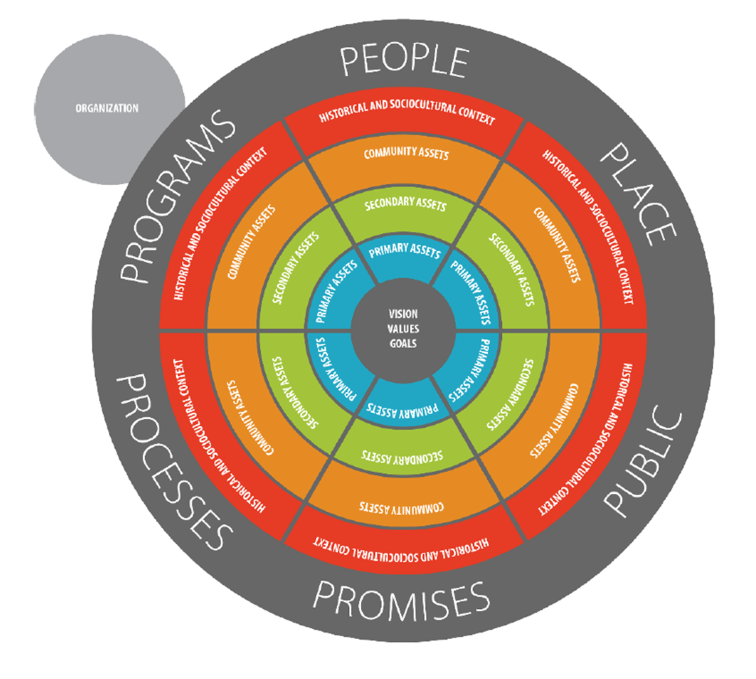**

**Appendix B Resource Mapping: Tiered Approach to School System of Health Supports**

**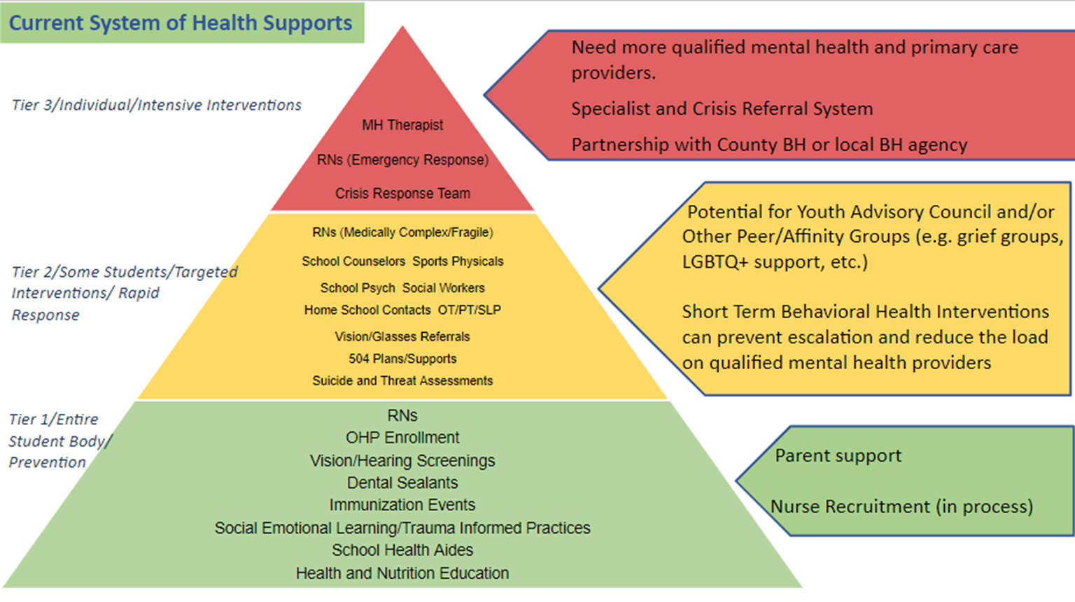**

**Appendix C: Resource Mapping, Tiered Approach to School System of Health Supports**

**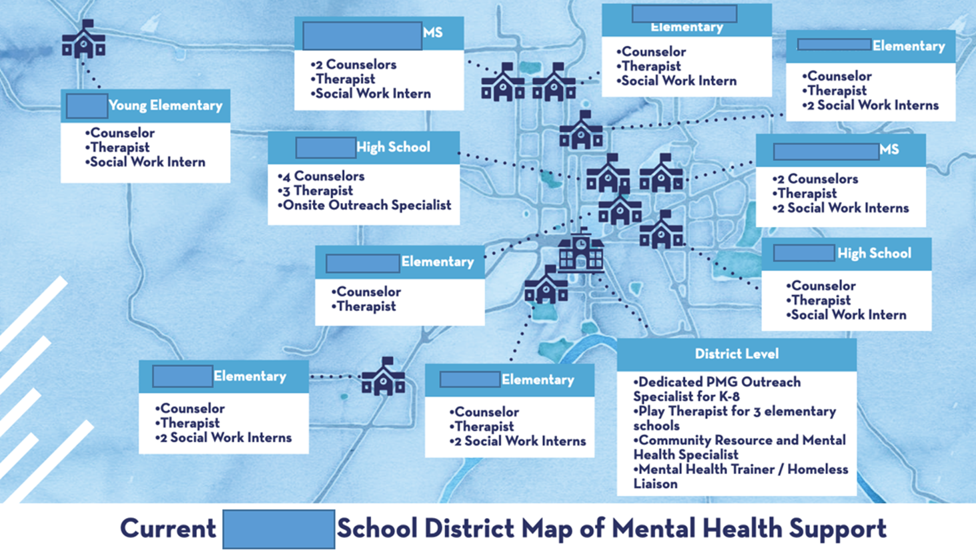**

**Appendix D** **Resources for Data and Information:**

**GENERAL INFORMATION ABOUT THE SCHOOL AND SCHOOL DISTRICT**

National Center for Educational Statistics [http://nces.ed.gov](http://nces.ed.gov/)

Colorado Department of Education <http://www.cde.state.co.us/>

GreatSchools: The Parents Guide [www.greatschools.net](http://www.greatschools.net/)

**DETAILED INFORMATION (DATA) ABOUT THE SCHOOL COMMUNITY**

Colorado Department of Education Statistics <http://www.cde.state.co.us/cdereval>

**ABOUT THE COMMUNITY/COUNTY**

Active Colorado Municipalities <https://dola.colorado.gov/lgis/lgActiveAlpha.jsf>

US Census Bureau <https://data.census.gov/cedsci/>

Best Places to Live [www.bestplaces.net](http://www.bestplaces.net/)

**Health**

CoHID - CDPHE Colorado Health Information Dataset <https://www.colorado.gov/pacific/cdphe/center-health-and-environmental-data>

KIDS COUNT - Colorado Children’s Campaign <http://www.coloradokids.org/data/>

Colorado Maternal Child Health Indicators <https://www.colorado.gov/pacific/cdphe/mch-data-and-reports>

Colorado Health Institute

<https://www.coloradohealthinstitute.org/research/school-based-health-care-opportunities>

[www.coloradohealthinstitute.org](http://www.coloradohealthinstitute.org/)

Colorado Rural Health [www.coruralhealth.org](http://www.coruralhealth.org/)

Healthy Kids Colorado Survey data tables and reports <https://www.colorado.gov/pacific/cdphe/healthy-kids-colorado-survey-data-tables-and-reports>